**Supplementary Information**

**Biological manganese oxidation in biofilms from oxygen-supplemented biological activated carbon (BAC) filters**

Amanda Larasatia , Olga Bernadeta,b , Gert Jan W. Euverinkb, Pieter H.J. van Veelena, and Maria Cristina Gaglianoa*

a Wetsus, Center of European Excellence in Water Technology, Oostergoweg 9, 8911 MA, Leeuwarden, The Netherlands

b Engineering and Technology Institute Groningen, University of Groningen, Nijenborgh 4, Groningen, The Netherlands

*Corresponding author: M. Cristina Gagliano [cristina.gagliano@wetsus.nl](mailto:cristina.gagliano@wetsus.nl)

**Figures**

**Figure S1 -** Schematic overview of the water treatment line at Ultrapure water (UPW) factory located in Nieuw-Amsterdam, the Netherlands. The biological activated carbon (BAC) filters are named biological oxygen-dosed activated carbon (BODAC), since are operated with pure-oxygen being dosed to the system to maintain the aerobic condition and stimulate biodegradation. DS: Drum sieve (opening size 1 mm), UF: Ultrafiltration (pore size 0.04 µm), RO: Reverse osmosis, EDI: Electrodeionization, and WWTP: Wastewater treatment plant.

***Description for Fig. S1***

The BODAC filters are comprised of two consecutive BAC filters, BODAC 1 and 2, where oxygen is dosed at their influent. The influent of BODAC 1 comprised ultrafiltration (UF) permeate, while BODAC 2 influent consisted of the effluent of BODAC 1. The empty bed contact time (EBCT) of BODAC 1 and 2 are 16 and 32 min, respectively (van der Maas et al., 2020). The oxygen consumption in these BAC filters varied between 5 – 40 mg O2/L (van der Maas et al., 2009). Periodical backwashing with air and water (from BODAC 2 effluent) is applied to decrease pressure build-up due to the accumulation of (bio)solids and avoid excess biofilm growth.

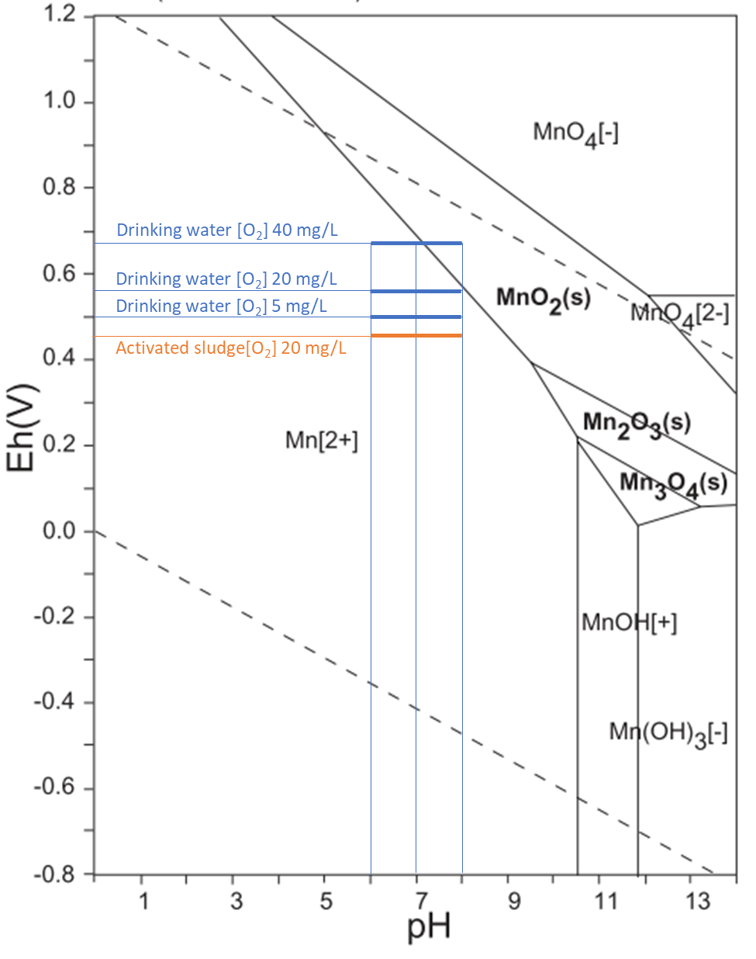

**Figure S2** – Pourbaix diagram for manganese, adapted from Takeno, 2005 to include values for drinking water and activated sludge.

***Description for Figure S2***

As mentioned in the description for Fog. S1, the BODAC filters were dosed with pure oxygen, and the oxygen consumption in the filters ranged from 5 to 40 mg O2/L (van der Maas et al., 2009). We estimated the redox potential (Eh) based on the dissolved oxygen concentration [O2] in the system. Initially, we estimated the Eh in activated-sludge reactors condition at pH 7 (Heduit and Thevenot, 1989).

1. [O2] = 5 mg/L, Eh = 0.46
2. [O2] = 15 mg/L, Eh = 0.47
3. [O2] = 40 mg/L, Eh = 0.50

As a comparison in a drinking water system, the maximum Eh values obtained with dissolved oxygen concentration at 8 mg/L and pH 7 was around 0.59 and increased steadily + 0.005 with every increase of 1 mg/L of dissolved oxygen concentration (James et al., 2004). It can be estimated that the redox potential in drinking water when dissolved oxygen concentrations 5, 15, and 40 mg/L are 0.51, 0.56, and 0.68, respectively. These values can be lower in the inlet of BODAC filters because the redox potential is not solely affected by the oxygen concentration but also by the presence of organic matter, the salinity of the water, and temperature.

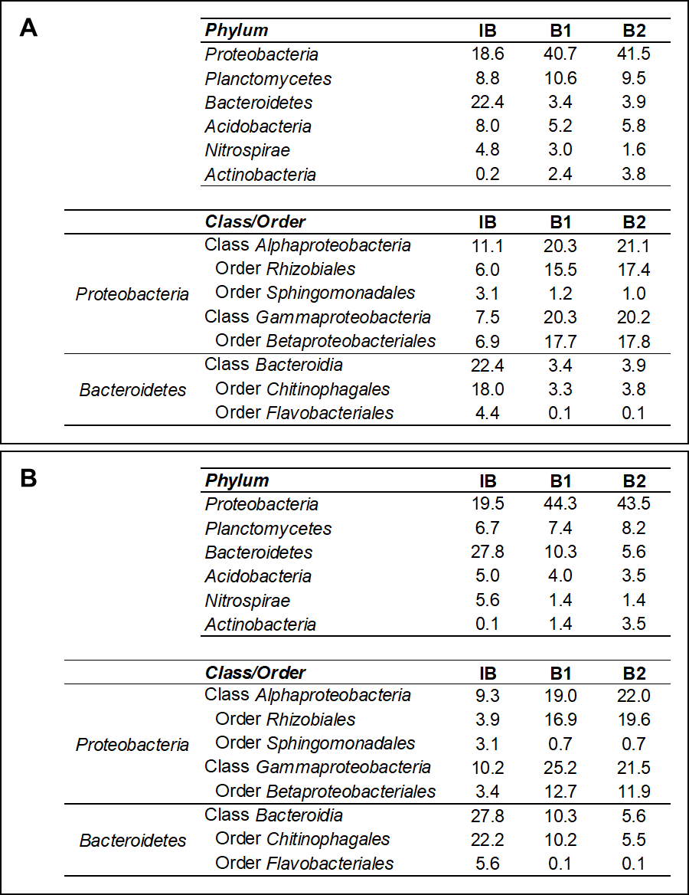

**Figure S3** – Relative abundances of the main phyla, classes and orders of the domain *Bacteria* identified into the inoculum biofilm (IB) sampled in September (in A) and January (in B) for each of the duplicate experimental cultures analysed via 16S rRNA gene amplicon sequencing (B1 and B2).

**Tables**

**Table S1 –** Analysis of water samples harvested to collect the inoculum biofilms from the BAC filters during the two campaigns in September 2021 and January 2022 (n = 2).



**Materials and Methods for Table S1**

* *Total chemical oxygen demand, nitrogen, and phosphate*

Total chemical oxygen demand (tCOD) and total nitrogen (tN), and total phosphate (tP) were determined using Hach Lange cuvette tests (Hach Lange, US): LCK 314 for tCOD, LCK 138 for tN, and LCK 349 for tP following the manufacturer’s instructions. The sample volume required for each replicate measurement for tCOD, tN, and tP was 2, 1.3, and 2 mL, respectively.

* *Cations, anions, and elements measurement*

Cations and anions were determined in the soluble fraction of the water samples, filtered using 0.45 μm PFTE filters. Cations (NH4+, Ca2+, and Na+) were measured using Ion chromatograph Compact IC Flex 881 and Compact IC Flex 930 (Metrohm AG, CH) equipped with a Metrosep C4 – 150/4.0 mm column (Metrohm AG) and 3 mM nitric acid as the mobile phase. The injection volume of the sample was 100 µL. Anions (Cl-, NO2-, NO3-, PO43-, and SO42-) were measured using Ion Chromatograph Compact IC 761 (Metrohm AG) using a Metrosep A Supp 5, 150/4.0 mm column. The first mobile phase consisted of 3.2 mM sodium carbonate, 1 mM sodium bicarbonate, and 1% (v/v) acetone. The second mobile phase consisted of 0.5 mM orthophosphoric acid and 1% (v/v) acetone. The injection volume of the sample was 20 µL.

Elements were measured using Optima 5300 DV Inductively Coupled Plasma Optical Emission Spectroscopy (ICP-OES) (Perkin Elmer, US) with argon as the carrier gas. An internal standard of Yttrium (Y) (Fluka, CH) was used.

**Table S2 -** Evaluation of the Mn speciation measurement with Inductively Coupled Plasma Optical Emission Spectroscopy (ICP-OES).



**Materials and Methods for Table S2**

*Manganese oxidation state characterization*

As a method development, four Mn salts (Table S2) were tested based on their Mn oxidation state solubility in nitric acid (HNO3). Mn(II) in manganese chloride (MnCl2) and manganese carbonate (MnCO3) should be soluble or become soluble in the acid of HNO3 1 M. Mn in Mn3O4 shall be partially soluble as it contains Mn(II) and Mn(III) speciation, while Mn in MnO2 should not be soluble in HNO3 1 M and become soluble with the assist of microwave digestion using of HNO3 and hydrogen peroxide (H2O2) (Characteristic Reactions of Manganese (Mn2+), 2020 and Neaman et al., 2004).

**References:**

Heduit, A., Thevenot, D., 1989. Relation between redox potential and oxygen levels in activated-sludge reactors. Water Science and Technology 21, 947–956.

James, C.N., Copeland, R.C., Lytle, D.A., 2004. Relationships Between Oxidation-Reduction Potential, Oxidant, and pH in Drinking Water. Presented at the American Water Works Association Water Quality and Technology Conference.

Neaman, A., Waller, B., Mouélé, F., Trolard, F., Bourrié, G., 2004. Improved methods for selective dissolution of manganese oxides from soils and rocks. European Journal of Soil Science 55, 47–54. https://doi.org/10.1046/j.1351-0754.2003.0545.x

Takeno, N., 2005. Atlas of Eh-pH diagrams Intercomparison of thermodynamic databases. National Institute of Advanced Industrial Science and Technology Tokyo 285.

van der Maas, P., Majoor, E., Schippers, J.C., 2009. Biofouling Control by Biological Activated Carbon Filtration: a Promising Method for WWTP Effluent Reuse, in: IWA Membrane Technology Conference. Presented at the IWA Membrane Technology Conference, Beijiing, China.

van der Maas, P., Veenendaal, G., Nonnekens, J., Brink, H., de Vogel, D., 2020. Biologische actiefkoolfiltratie met zuurstofdosering: veelbelovende techniek voor verwijdering geneesmiddelen? H2O/Waternetwerk.

Chemistry LibreTexts. 2020. Characteristic Reactions of Manganese (Mn2+). [online] Available at:

<https://chem.libretexts.org/Bookshelves/Analytical_Chemistry/Supplemental_Modules_(Analytical_Chemistry)/Qualitative_Analysis/Characteristic_Reactions_of_Select_Metal_Ions/Characteristic_Reactions_of_Manganese_Ions_(Mn%C2%B2%E2%81%BA)>> (Accessed 20 June 2022).